|  |  |
| --- | --- |
|  | *Abstract*  **Visualisation And Analyse With Rstudio & PowerBi**  Nahid March 2023 |

**Contents**

Task1 Rstudio ………………………………………………………………………….…………………………………….2

Task2 PowerBi……………………………………………………………………………………………………..……….6

**Load data**

**Take a look at the data**



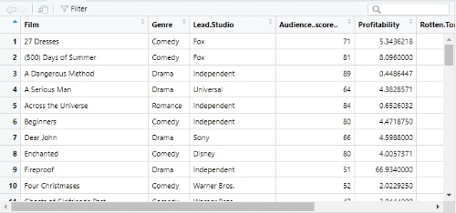

**Load library**

**Import library**

**library(tidyverse)**

**Check data types:**

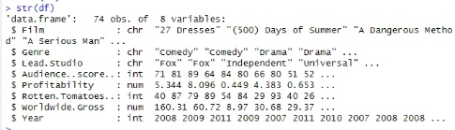

**install. Packages("tidyverse")**

**Check for missing values:**



**Drop missing values**

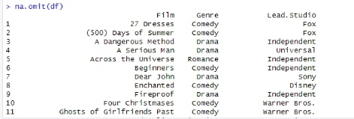

**check to make sure that the rows have been removed**

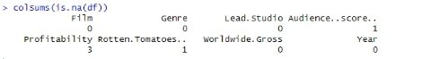

**Check for duplicates**

**round off values to 2 places**

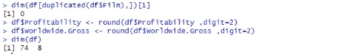

**Check for outliers using a boxplot**



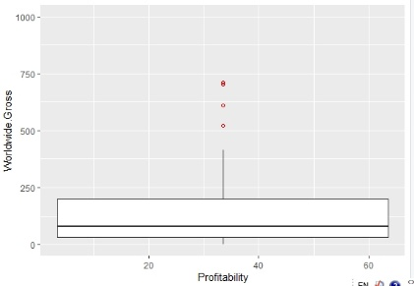

**Remove outliers in Profitability**

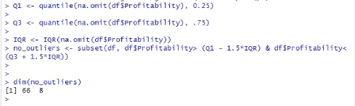

**Remove outliers in Worldwide.Gross**

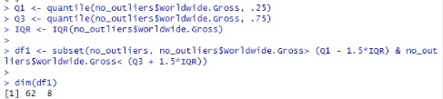

**Summary Statistics/Univariate Analysis**

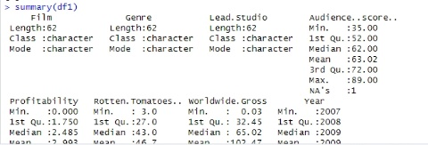

**bivariate analysis**

**scatterplot**



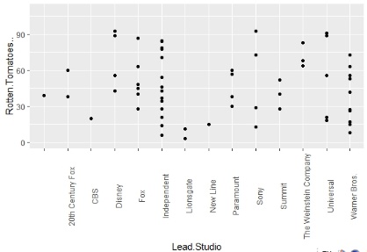

**bar chart**

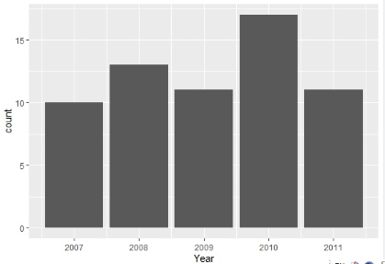

**Export clean data**



**The average Rotten Tomatoes ratings of each genre**

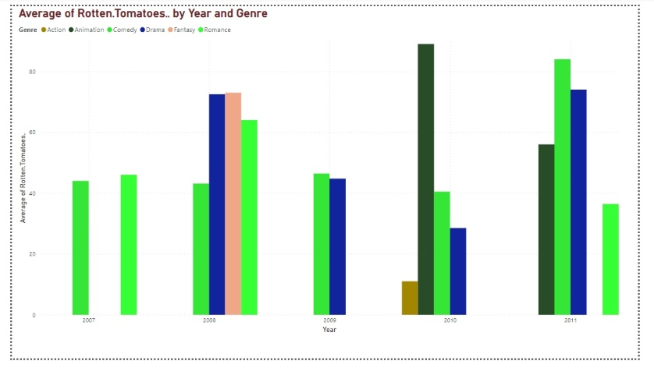

**The number of movies produced per year**

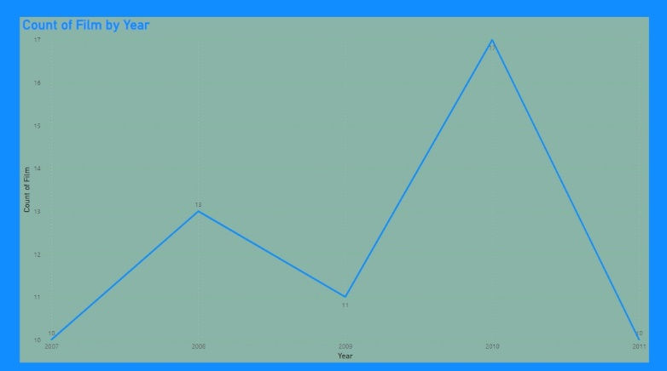

**The audience score for each film**

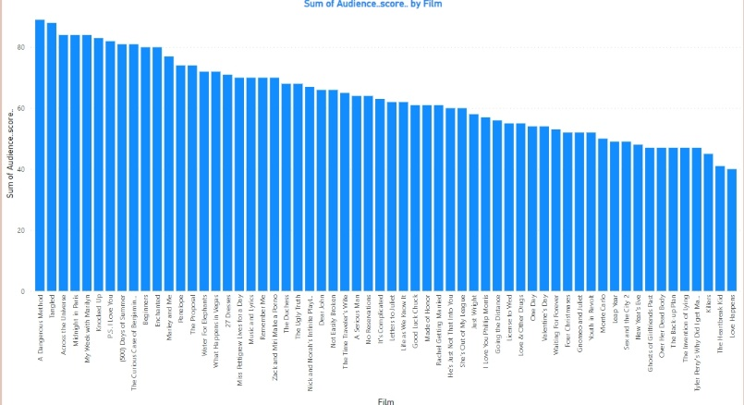

**The profitability per studio**

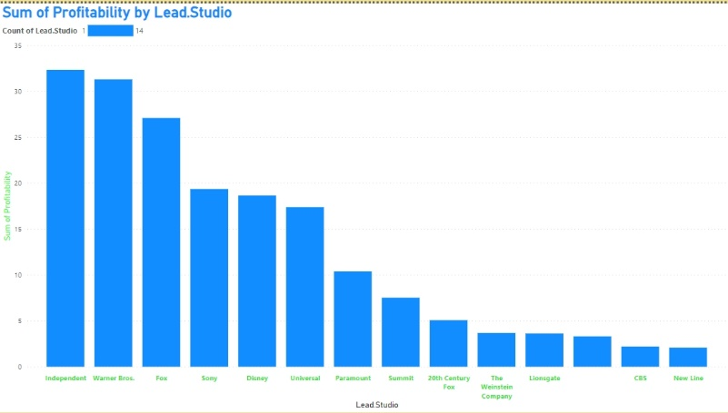

**The worldwide gross per genre**

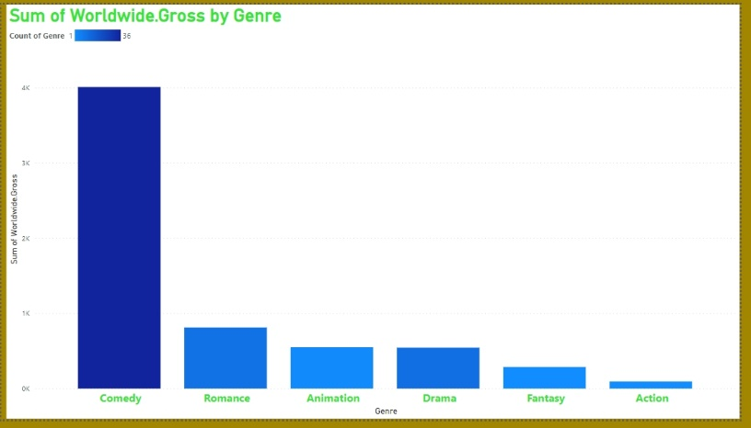

**Dashboard**

